Forecasting South Mountain Caribou Population: 10 & 30 years projection with human intervention

Trang Minh Phan

T00661694

Bob Galgardi School of Business and Economics, Thompson Rivers University

ECON 4330: Forecasting in Business and Economics

Dr. Mohammad Mahbobi

December 13, 2024

# Abstract

The main objective of this project is to evaluate Lamb et al. (2024) research on south mountain caribou conservation and the methodology of conservation through forecasting and descriptive statistic evaluation. This research project will evaluate the caribou population with two models of machine learning. The data includes population inference methodology to evaluate the effectiveness of conservation effort. Overall, the human inference in population control creates a recovery effect and slowing down of extinction rate until 2033. The result aligns with Lamb’s finding (2024) of the effectiveness of human intervention. However, the extinction rate is expected to continue, and the species will disappear in 2040. The paper disagrees on Lamb’s standing ground of advocating for wolf reduction method (2024). It is founded that maternal penning and supplemental feeding have stronger impact on the herd’s growth. The wolf reduction will only have positive effect if by doing less or combining with other previously mentioned recovery methods.

# Introduction

British Columbia (BC) holds the majority, about 98%, of caribou population in the world which is underlined as the environmental flagship in this area (Ministry of Environment, Lands, Parks, 1999). Caribous even though imply passive value to the national economy, they also have a major role in cultural value of indigenous community. Maher et al. (2020) mention that caribous bearing cultural values to society will have incremental effect on the economic well-being, yet its value is being ignored in the calculation. This statement is supported by Yun et al. (2017) who state that economic decision making should be broadened to include ecological values in the calculation for better sustainable resource management. Hence, the focus of this forecasting paper is to determine the effectiveness of BC caribou recovery effort through human interference using ForecastX, Minitab and Eview13. The paper will challenge the aspect from Clayton Lamb and his team on utilizing wolf reduction method as the main cure to recover the herds.

# Research Objectives

The paper will analyze and forecast caribou population in 2033 and 2053. The 10-year forecasting is to evaluate the treatment effectiveness through maternal penning (from 2015 to 2023), wolf reduction and sterilization (from 2002 to 2023). 30 years forecasting will illustrate the population trend if the BC Caribou Recovery Program is making enough effort to recover the herd in long term, or the extinction chance still exists. From the result, it will be concluded if more resource investments should be directed into BC Caribou Recovery Program.

# Literature Review

Southern mountain caribous are enlisted as Threatened Species under Species At Risk Act (Parks Canada Agency, 2024). The species degenerating rate is related not only to natural disturbance such as climate change, wildfires but also human activities such as forestry harvesting, mining, pipelines and forestry road access (Smyth et al., 2020 & Maltman et al., 2024). It is needed to run against time and recover the species that holds spiritual value to the Indigenous people specifically and passive economic value to Canada in general. Hence, Hauler et al. (2018) and Maher et al. (2020) suggest other methods of conservation including maternity pens and predator suppression. To support this perspective, Lamb (2024)’s research focuses on gathering data from the past 51 years (1973-2023) on caribou population surveys across 40 regional herds to evaluate on the human intervention treatment effect. Lamb et al. (2024) finds that the recovery treatment performs efficiently in less human-activity ecological setting. It implies the limits of predator suppression or maternal penning treatment in well-developed and open-access forest area (Lamb et al., 2024). The research paper continues to advocate for predator reduction along with other population control method to regenerate the southern mountain caribous.

# Methodology

ForecastX and Minitab are the two main software to be used, analysed and forecasted the data set. Afterwards, the results will be combined using Eview13 to generate a neutral forecasting result. ARIMA model will be performed through Minitab to predict BC caribou population in 10 years and 30 years. This model is built based on three components: AutoRegressive (AR), Intergrated (I), and Moving Average (MA). It is applicable to analyze a data set with historical trend and seasonal patterns, particularly, caribou population. The model is evaluated based on minimizing Akaike Information Criterion (AIC)s with the confidence interval up to 95%.

Another model to utilize in the project is Multiple Regression in ForecastX. This model will rely on the historical population survey as dependent variable. To evaluate the population recovery method, data such as maternal penning, wolf reduction, moose reduction, and wolf sterilization will be implemented as independent variables aside from the regional herds independency. The model will provide an equation to further discuss and give recommendation for future caribou recovery strategy.

# Data Description

The data is retrieved from the government website *Knowledge Management Branch of BC Environment and Climate Change Strategy* from 1973 to 2023 for 40 caribou ecotypes (Lamb et al., 2024). The data was cleaned and organized by Lamb et al. (2024) to demonstrate different herds and treatments performed on South Mountain caribous. The data is reordered in this research to narrow down the four main subpopulations which will be used as independent variables including Itcha-Ilgachuz, Chase, Hart South and Wolverine. Other independent variables will present the recovery effort through human interference such as number of wolf reduction, maternal penning setups, number of moose reduced throughout the year, the wolf population being sterilized and the transplant throughout the regions.

# Empirical Results

## 10 Years Forecasting

### ARMIA method (1,2,3)

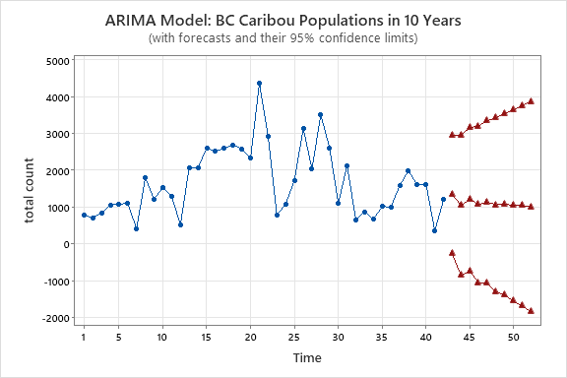

Figure 1: Forecasting BC Caribou Population in 10 Years with ARIMA Model (Source: Minitab)

In this model setup, the data is analyzed and compared against 35 other models, with the model exhibiting the lowest Akaike Information Criterion (AIC) being selected. The data is solely based on caribou annualy surveys from the past 51 years. The autoregressive (AR) parameter pp and the moving average (MA) parameter qq are varied from 0 to 5, with a second-order differencing applied to ensure stationarity. The forecasting is conducted based solely on the observed data pattern, and the treatment effect is incorporated into the overall population pattern to assess its influence.

|  |  |  |  |  |
| --- | --- | --- | --- | --- |
| **Type** | **Coef** | **SE Coef** | **T-Value** | **P-Value** |
| AR   1 | -0.670 | 0.161 | -4.16 | 0.000 |
| MA   1 | 0.693 | 0.167 | 4.15 | 0.000 |
| MA   2 | 0.938 | 0.121 | 7.74 | 0.000 |
| MA   3 | -0.659 | 0.144 | -4.57 | 0.000 |

Table 1: Estimates of Parameters (retrieved from Minitab)

Table 1 suggests that the ARIMA model is well-calibrated with p-value equals to 0, meaning all coefficients are statistically significant. In addition, Moving Average (MA) term 1, 2 and 3 has positive and negative effect which illustrating that the model captures both short-term and long-term dependencies in the error terms.

The observation reveals a positive movement in the 10-year projection, with two significant fluctuations occurring between 2024 and 2028. After these fluctuations, the population stabilizes around the 1000s over the subsequent 5 years. This trend suggests a positive response to recent treatments; however, it also highlights the need for continued efforts to further increase the population.

### Multiple Regression Model

Figure 2: Forecasting BC Caribou Population in 10 years using Multiple Regression Model (Source: Forecast X)

Model equation:

total count = -150,562.75 + ( (year) * 76.07 ) + ( (Wolf Reduction) * -78.15 ) + ( (Feed) * 127.03 ) + ( (Pen) * -62.54 ) + ( (Reduce Moose) * -194.66 ) + ( (Sterilize Wolf) * 26.92 ) + ( (Transplant) * -226.16 ) + ( (Itcha-Ilgachuz) * 0.788714 ) + ( (Chase) * 1.90 ) + ( (Hart South) * 1.55 ) + ( (Wolverine) * 1.18 )

The result observation indicates a fluctuation in the population from 2024 to 2027, followed by a downtrend, with an unexpected peak of 1512.70 caribous in 2031. Despite the overall decline, the population shows a stable fluctuation, and the rate of extinction is slowing down comparing to 2010’s steep declining. Also, the equation indicates a strong positive effect from feeding (127.03) and penning (62.54) and sterilizing wolf (26.92) on the population growth while discouraging the wolf and moose reduction (respectively -78.15 and -194.66).

## 30 Years picture

### ARIMA Model (1,2,3)

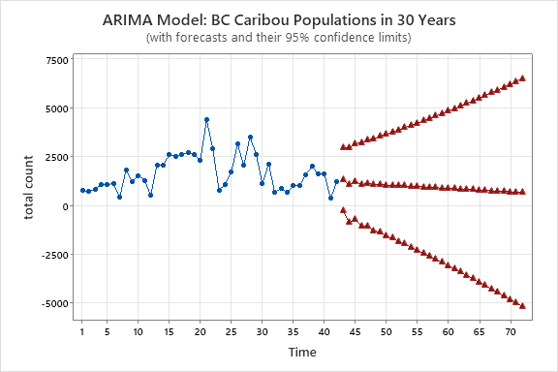

Figure 4: Forecasting BC Caribou Populations in 30 years using ARIMA Model (Source: Minitab)

The result observation shows a clear downtrend, characterized by a slow but noticeable deceleration of extinction rate in the population. This suggests a gradual reduction, though the rate of decline is slowing over time. Other measurement discussed in 10-year forecast remains constant.

### Multiple Regression

Figure 5: Forecasting BC Caribou Population in 30 years using Multiple Regression Model (Source: Forecast X)

Model equation:

total count = -150,562.75 + ( (year) * 76.07 ) + ( (Wolf Reduction) * -78.15 ) + ( (Feed) * 127.03 ) + ( (Pen) * -62.54 ) + ( (Reduce Moose) * -194.66 ) + ( (Sterilize Wolf) * 26.92 ) + ( (Transplant) * -226.16 ) + ( (Itcha-Ilgachuz) * 0.788714 ) + ( (Chase) * 1.90 ) + ( (Hart South) * 1.55 ) + ( (Wolverine) * 1.18 )

The observed model in Figure 5 indicates that the stable fluctuation described in part 1a) is unlikely to persist, as it is followed by a sharp decline, with the last herd remaining in 2042. The slight peak in 2044 is scientifically implausible, as once the herd population reaches zero, consequently the recovery is not possible. This projection aligns with the downward trend indicated by the ARIMA model but places a stronger emphasis on extinction, raising concerns about whether the recovery efforts are sufficient to regenerate growth.

### Measure comparison for both methods

Below is the measurement of accuracy obtaining from Minitab and ForecastX.

|  |  |  |
| --- | --- | --- |
| Method | ARIMA | Multiple Regression |
| AIC | 661.88 | 593.05 |
| BIC | 670.33 | 594.79 |
| MAPE | 0.5471 | 0.1766 |
| RMSE | 777.08 | 275.17 |
| Theil | 0.80 | 0.33 |

Table 2. Accuracy Measures Comparison

AIC value is used to evaluate the best performance forecasting model that yields not only high accuracy but also realistic approximation (Keating et al., 2019). Bayesian criterion (BIC) is similar to AIC and is used to evaluate a model based on its goodness of fit and complexity (Keating et al., 2019). In this case, multiple regression has the lower AIC and BIC value comparing to ARIMA. This suggests the model is a better fit in forecasting the data for caribou population. Mean absolute percentage error (MAPE) calculates average percentage difference from the prediction and the actual population (Roberts, 2023). From Table 2, it shows that multiple regression model only has 17.76% prediction error from the actual value comparing to 54.71% chance difference coming from ARIMA model. Root mean square errors (RMSE) further emphasizes the accuracy of multiple regression application for this data set by implicating its prediction is closer to actual value than ARIMA model (275.17 > 777.08). Lastly, Theil Index supports the reliability and accuracy of multiple regression model by showing the value closer to 0.

## Combining Forecasts

### 10 years & 30 years

Since both models contain valuable insights considering they are both agreeable on the population down trending, an attempt in combining the models into a singular forecasting pattern was conducted. With the support from Eview13, Appendix 1 and Appendix 2 show the combined data (red line) will create a neutral forecasting.

|  |  |  |  |
| --- | --- | --- | --- |
| Method | ARIMA | Multiple Regression | Combined Model |
| MAPE | 0.5471 | 0.1766 | 0.3281234 |
| RMSE | 777.08 | 275.17 | 464.11744 |

Table 3. Accuracy Measures Comparison with Combined Model

Table 3 showcases the neutral ground of the new model with the RMSE value stands between ARIMA’s and multiple regression’s. This suggests that multiple regression model has higher performance and less bias than combining both models.

# Discussion

The analysis shows an improvement in herd population over the next 10 years, aligning with Lamb (2024) findings using the population-inference method. This suggests that recovery efforts are on track, particularly through effective short-term measures like wolf reduction. However, the ARIMA model appears to have higher prediction errors but offer a slow declining population forecasting. In contrast, multiple regression model incorporates the effects of independent variables, offering higher accuracy prediction, yet a greater negative outlook on the population trend.

Over the period from 2031 to 2033, significant changes driven by these variables support a stable population recovery, which is ignored by the ARIMA model (Figure 3), but captured in the multiple regression model (Figure 4). This highlights the importance of considering independent variables such as human intervention which ARIMA model overlooks. Furthermore, the coefficient relationships in the multiple regression model provide valuable insights into the effectiveness of human interventions, suggesting that appropriate treatments strongly influence population dynamics.

On the other hand, the multiple regression model has a strong conflict with Lamb’s opinion on wolf reduction effect to caribou growth. In Figure 6 a), Lamb et al. (2024) illustrates the positive effect of wolf reduction stronger than supplemental feeding. This contradicts the multiple regression equation where wolf reduction holds a negative value of 78.15 whilst for feeding is a positive 127.03. Lamb (2024) produces the highest positive outcome in Figure 6b) by combining method of penning and predator removal which the multiple regression model supports. The research finding strongly challenges the Lamb et al.’s perspective on the effect of wolf reduction separately, nevertheless, support if this method is combined with other conservative actions that do no harm to the predators and ungulates. It is highly recommended to weighing more on the latter effort than the former method.

Figure 6: (a) the treatment effect using Lamb’s model (b) modeled outcomes of each recovery action compared to a status quo (no recovery action) scenario (Lamb et al., 2024)

# Conclusions

South mountain caribous hold not only spiritual values to the indigenous people but also passive values to the economy of Canada. There are monetary investments and human resources putting in to reverse the consequences of unnatural disturbances. This report is to evaluate if there has been enough effort to make an impact. The result concludes that there are positive changes in term of slowing down the extinction rate for the next 10 years. The forecasting data illustrate the success of planned treatments. However, in 30-year projection, the forecasted data shows that the effort to recover the herds is not enough. This suggests increasing the investment in performing human interference to make larger impact and reverse the extirpation. Solely reducing predators is not the answer to the solution. It is recommended to BC Caribou Recovery Program to invest more on other passive treatments to the caribou herds such as old growth forest conservation (Smyth et al., 2020; see also Maltman et al., 2024), maternal penning and supplementary feeding.

# Future Research

This paper is the starting point for the next undergraduate research project called “Economic Analysis of Caribou Conservation in British Columbia” funding through UREAP. In general, the models in this paper eliminate geological ecotypes. The data was used as a lump-sum rather than treatment per region. As a result, dividing based on treatment plans and regions may yield a deeper perspective on the effect of human interference to the population. Furthermore, the research paper can be further improved with other independent variables that connects to the extinction such as wildfire events, forest harvesting density, and snow elevation factors. Those are the elements of natural disturbance to caribou habitat. Besides that, the result above will be connected to advise for caribou recovery funding if further investments should be made to create more impact onto the population recovery.

# References

Clayton Lamb. (2024). ctlamb/CaribouIPM_BCAB: Lamb et al. 2024 Zenodo commit for Ecological Applications Paper v3. Zenodo. <https://doi.org/10.5281/zenodo.10834654>

*Hauer, G., Adamowicz, W. L., & Boutin, S. (2018). Economic analysis of Threatened Species Conservation: The case of Woodland Caribou and Oilsands Development in Alberta, Canada. Journal of Environmental Management, 218, 103–117. https://doi.org/10.1016/j.jenvman.2018.03.039*

*Keating, B., & Wilson, J. H. (2019). Forecasting & predictive analytics: With ForecastX. McGraw-Hill Education.*

Lamb, Clayton T., Sara Williams, Stan Boutin, Michael Bridger, Deborah Cichowski, Kristina Cornhill, Craig DeMars, et al. 2024. “Effectiveness of Population-Based Recovery Actions for Threatened Southern Mountain=Caribou.” Ecological Applications 34(4): e2965. https://doi.org/10.1002/ eap.2965

Maher, S. M., Fenichel, E. P., Schmitz, O. J., & Adamowicz, W. L. (2020). The economics of conservation debt: a natural capital approach to revealed valuation of ecological dynamics. *Ecological Applications, 30*(6):e02132.10.1002/eap.2132

*Maltman, J. C., Coops, N. C., Rickbeil, G. J., Hermosilla, T., & Burton, A. C. (2024). Quantifying forest disturbance regimes within Caribou (Rangifer tarandus) range in British Columbia. Scientific Reports, 14(1). https://doi.org/10.1038/s41598-024-56943-0*

Ministry of Environment, Lands and Parks. (1999). *Mountain caribou*. ISBN 0-7726-7671-2

OpenAI. (2024). Assistance with grammar correction. ChatGPT. <https://chat.openai.com/>

*Parks Canada Agency, G. of C. (2024, July 16). Southern Mountain Caribou Conservation. Nature and science.* [*https://parks.canada.ca/nature/science/especes-species/caribou*](https://parks.canada.ca/nature/science/especes-species/caribou)

*Roberts, A. (2023, February 10). Mean absolute percentage error (MAPE): What You need to know . Arize AI.* [*https://arize.com/blog-course/mean-absolute-percentage-error-mape-what-you-need-to*](https://arize.com/blog-course/mean-absolute-percentage-error-mape-what-you-need-to) *know/#:~:text=point%20in%20time). ,Mean%20absolute%20percentage%20error%20measures%20the%20average%20magnitude%20of%2 error,and%20the%20actuals%20is%2020%25.*

*Smyth, C. E., Xu, Z., Lemprière, T. C., & Kurz, W. A. (2020). Climate change mitigation in British Columbia’s forest sector: GHG reductions, costs, and environmental impacts. Carbon Balance and Management, 15(1). https://doi.org/10.1186/s13021-020-00155-2*

Yun, S. D., Hutniczak, B., Abbott, J. K., & Fenichel, E. P. (2017). Ecosystem Based Management and the Wealth of Ecosystems. *Proceedings of the National Academy of Sciences USA* 114:6539–6544*.*

# Appendices

# 

Appendix 1. 10 years forecasting combined (retrieved from EView13)

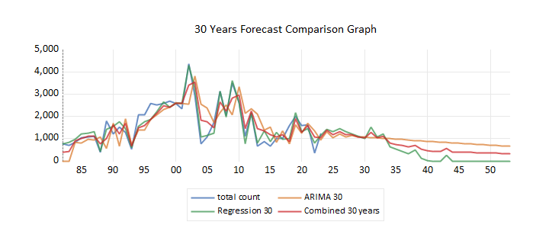

Appendix 2. 30 years forecasting combined (retrieved from EView13)