**Critical Policy Review: How BC old-growth forest policy help conserve caribou population?**

By

Thi Phan

Bob Gaglardi School of Business and Economics

Thompson Rivers University

Email: phant191@mytru.ca

**Abstract**

The main objective of the project is to enhance the policy connection between old growth forest preservation and caribou conservation strategy. Caribou species rely on old-growth forest to provide lichen as its main food source. British Columbia has developed policies to protect old-growth forest and indirectly protect caribou habitat. Besides that, there are other methods to preserve this species, for example, predator control like wolf reduction or nutrition enhancement like maternal penning. However, these methods are targeting short-term species conservation. A significant amount of old-growth forest needs to be reserved for caribou restoration as part of long-term forestry planning. However, this will lead to a substantial opportunity cost in terms of lost logging revenue for the British Columbia economy. The critical question then becomes as to how policymakers can balance the logging revenue in forestry lost and contribute the ecosystem services value of sustaining a healthy caribou habitat in the old growth forest. The goal of this project is to demonstrate that preserving old-growth forests can significantly enhance British Columbia's ecosystem services and natural capital through the maintenance of a viable caribou population. This research conducts a comprehensive review of the current forest preservation policies and offers a critical analysis on how these policies can be enhanced to serve as effective strategic tools for caribou conservation.

**Keywords: Caribou Population, Policy Review, Old Growth Forest, British Columbia, Economics of Conservation**

**Introduction**

British Columbia (BC) has a total land area of 95 million hectares, 64% of which is forested land, according to the Government of British Columbia (2016). Of the area designated for managed forestry, approximately 11.1 million hectares, or 20%, is old-growth forest, as reported by the Ministry of Forests (2024). Old growth forest is home to caribou’s natural habitat. Despite an intensive large area of old growth forest being available to caribou habitat, it is still being threaten due to human disturbance activity such as forest harvesting or gas pipeline expansion (Cichowski et al., 2022).

Forestry harvesting and linear fragmentation disturbs caribou habitat in multiple aspects. First, it destroys caribou’s main food sources, lichens (Cichowski et al., 2022). Secondly, it decreases the forest density which leads to easier attack pathways for predators on caribou (James et al., 2000). Other activities that affect the caribou species includes noise disturbance and linear interruptions such as logging roads, pipeline development (Maher et al., 2020 and Maltman et al., 2024).

To counteract the unnatural disruptions mentioned above and protect caribou populations, several recovery methods have been proposed. These include eliminating land alteration due to human activities, increasing nutrient feeding by implementing maternal penning, and reducing populations of wolves and moose (Maher et al., 2020). According to Johnson et al. (2019)’s caribou-moose-wolf model, wolf reduction is proven to be the most cost-efficient method in short term to recover Chinchaga herds in British Columbia. However, maternal penning would work more effectively on Charlevoix herds in Quebec due to the demographic and habitat variance (Johnson et al., 2019).

With the predator-prey dynamic control applied widely, Ehlers et al. (2016) argues that the confrontation between caribous and wolfs are insignificant. The prey-predator dynamic between two species occurs in lower density area (Ehlers et al., 2016) which interconnected with frequent logging These direct interference methods are proven to be effective over short period but not for the long term (Mcnay et al., 2022). To establish a sustainable growing environment for caribou, old growth forest will provide resourceful lichen, the main food source for caribou, and forest density to protect them from predators in long term.

To preserve old-growth forests for caribou habitats, southern British Columbia has implemented management strategies for second-growth forests, as noted by Stevenson (1990). This method considers partial harvesting strategy selecting areas that do not affect wildlife habitat. Moreover, caribou rely on high-elevation forest to avoid potential predators. Selective harvesting and forestry planning can protect this species by logging the open areas and densifying old growth forests (Newsome et al., 2016).

In addition to sustainable harvesting practices in second-growth forests, the province of British Columbia mandates that forestry planning involves collaboration between wildlife experts and foresters (McKinnon, 1996). They aim to set boundaries on caribou-reserved forests and establish buffer zones to create a thriving living environment for caribou (McKinnon, 1996). Another conservation strategy is to apply the Cumulative or Bow-tie Risk Assessment (Winder et al., 2020). This method allows the active assessment of the caribou habitat dynamics and scenario analysis to holistically plan for policy of conservation.

Reserving old growth forest for caribou habitat not only protect the caribou but also provides benefits to Indigenous communities. Conservation funding programs, such as the First Nations Caribou Recovery Implementation Fund and the Caribou Recovery Program in British Columbia, can financially support the communities. These programs facilitate collaboration between First Nations communities and the government and offer a financial alternative to revenue from old-growth logging, as noted by Watt (2024). Furthermore, such collaborations will allow Indigenous-led projects to combine the cultural knowledge with scientific knowledge and create a holistic strategy for caribou recovery initiatives (Kutz, 2019).

This research aims to evaluate the policies concerning caribou conservation in British Columbia and assess their effectiveness in practice. The project will rely on secondary resources from the Government of BC website and the research resources cited in this literature review. The goal is to develop a balanced perspective on the issue and to identify areas for improvement to establish a more holistic approach to caribou conservation policy.

In the next section, a model will be built to illustrate the connection between caribou population and old-growth forest conservation. The theorical model is the foundation to discuss on current old-growth forest preservation and how it could affect caribou population in a large scale.

**The dynamics of the caribou populATION IN OLD GROWTH FORESTS**

Taylor and Weder (2024) developed a simple model to illustrate the economics of extinction. In this section their model is applied to the caribou population surviving or not in the old growth forests as stated in the introduction the caribou population is increasingly threatened by a combination of wolves, human-induced habitat degradation, and harvesting through hunting. To effectively manage and conserve these populations, it is crucial to understand the interplay between these factors and their cumulative impact on caribou dynamics. To illustrate let $C\left(t\right)$ represent the caribou population at time t then the dynamic time path over time can be represented by a simple logistic growth function as follows:

$$\frac{dC(t)}{dt}=gC\left(t\right)\left(1-\frac{C\left(t\right)}{K(L)}\right)\left(\frac{C\left(t\right)-M}{M}\right)-H\left(C\left(t\right)\right) (I)$$

where:

g is the growth rate of the caribou population, reflecting natural reproductive capabilities.

$K(L)$ represents the natural carrying capacity of the caribou in the presence of logging $L$ where increases in logging reduces the carrying capacity K, $\frac{dK}{dL}<0$

M represents the minimum number of caribou below which it becomes extinct.

$H(C\left(t\right))$ represents the hunting of caribou.

Also note that the following condition holds: $0<M<K(L)$.

Let $v(t)= \frac{M}{K(L)}$ represents the fraction of all initial caribou population levels below $K(L)$ which generates extinction in the presence of logging and the absence of human harvesting.

This simple model captures several critical dynamic forces. First, in the absence of logging, predation by wolves, and hunting, the caribou population would converge to the carrying capacity, K via the logistic growth path. However, logging operates to reduce the carrying capacity of the caribou to $K(L)$. This reduction in habitat not only limits space and resources available for caribou but also increases encounters between caribou and predators, potentially increasing predation. These two forces can accelerate the decline of the population, pushing it towards critical thresholds and extinction.

The harvesting of caribou is a linear function of predators human and wildlife. It represents the traditional and commercial hunting from human consumption and natural prey-predator relationship. The function presents the current harvesting pressure that directly impact the herd population. This impact can be shown through the graph below:

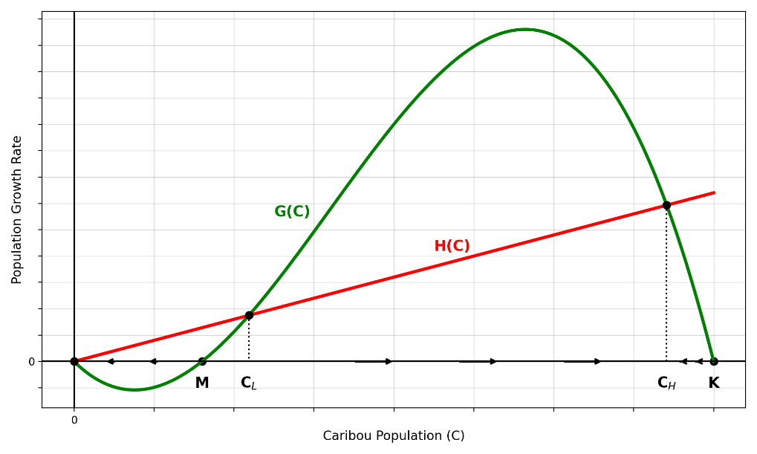

**Figure 1:** Taylor and Weder's extinction model in caribou population and old growth forest harvesting

H(C) intercepts with the population at three points: 0, CL, CH. The three values corresponding extinction in population, minimum and maximum caribou population capacity. The area between CL and CH represents the stable population where human and predator harvesting effect is less than the population growth rate. If the harvesting rate is more than the population growth rate (H(C) > gC(t)), the population will certainly extinct.

In the absence human interference, we have potential extinction by predators such as wolves or extreme climate conditions which will cause the caribou to drop below the minimum number, if $C\left(t\right)$ < M

$$\frac{dC(t)}{dt}=gC\left(t\right)\left(1-\frac{C\left(t\right)}{K}\right)\left(\frac{C\left(t\right)-M}{M}\right) (II)$$

Predators create a negative pressure on caribou growth rate, causing the caribous to migrate to higher elevation and density forest with more available food sources. Together without human impact on nature habitat through hunting and logging, caribou herds will return to its normal growth rate and its predator-prey relationship will return to natural balance.

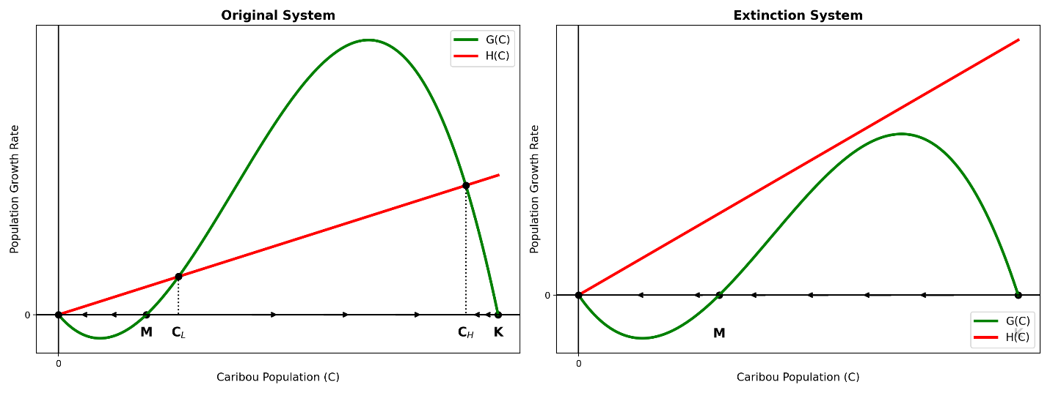

**Figure 2:** Taylor and Weder (2024)'s extinction model - on the left is the stable harvesting system and on the right is the overharvesting system leading to caribou extinction

If human interference in caribou habitats—especially through old-growth forest logging—continues to increase, the herd’s extinction will be inevitable. This trend is illustrated in Figure 2. A balanced system, where harvesting and population growth are sustainable (left figure), is being disrupted by overharvesting (right figure). This includes a sharp rise in predator populations and increased human hunting, both of which are intensified by old growth forest logging. It is due to logging operation not only reduces food sources for caribou but also makes the area more accessible to hunters. The increasing pressure from harvesting is represented by a steepening slope or a more elastic shift in the harvesting function. Eventually, this function will surpass the population growth function, leading to the inevitable extinction of the herd.

With three steady states, a few simulations will be run with caribou population surveys to observe the change in caribou herds in Cariboo, British Columbia. First, an analysis is needed to identify the study regions that show the population downtrends over time. After that, a micro-analysis on the target study block and apply the theory above to predict the population trend with regulated and unregulated harvesting policies.

**EVIDENCE FROM THE CARIBOO REGION**

Caribous’ territory lies within eight regions of British Columbia. However, this paper will focus on Cariboo region which have the highest population of caribous for population analysis. Cariboo region consists of five herds: Barkerville, Wells Gray North, Itcha-Ilgachuz, Rainbows and Charlotte Alplands (see Figure 3). These subpopulation boundaries are divided to for population management and subject to overlapping counts (Government of British Columbia, 2025).

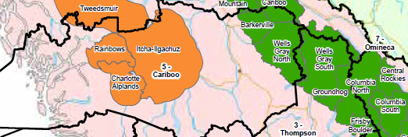

**Figure 3**:Cariboo region in BC[1]

The population data is retrieved from Wildlife Species Inventory Survey Summary (Government of British Columbia, n.d). The data also includes other species in the area including elk, sheep, moose, goat, etc but only caribou will be filtered as the central discussion of this paper. Moreover, Government of British Columbia (n.d) mentions that best parameter value indicates that the population survey is credible to be used for data analysis. Hence, the data is filtered to caribou population with the best parameter and narrowed to Cariboo region only.

Besides filtering the study region, there are many survey methods applied in the data set. The priority list is created based on the level of accuracy test. As a result, the data set is filtered by prioritizing the available methods including Expert Knowledge, Model Correction, Model or Correction - Joint Hypergeometric Estimator, Model or Correction - Lincoln-Peterson, Model or Correction & Expert Knowledge, and Observe Total Count. It is due to model correction and expert knowledge are the highly credible values in population survey methods in contrast to observe total counts (Conns et al, 2017).

Lastly, the data set has its own limit in inconsistent survey blocks throughout the years. It explains the missing points in each subpopulation. The populations will also be scaled to the natural logarithm for easier visualization purpose.

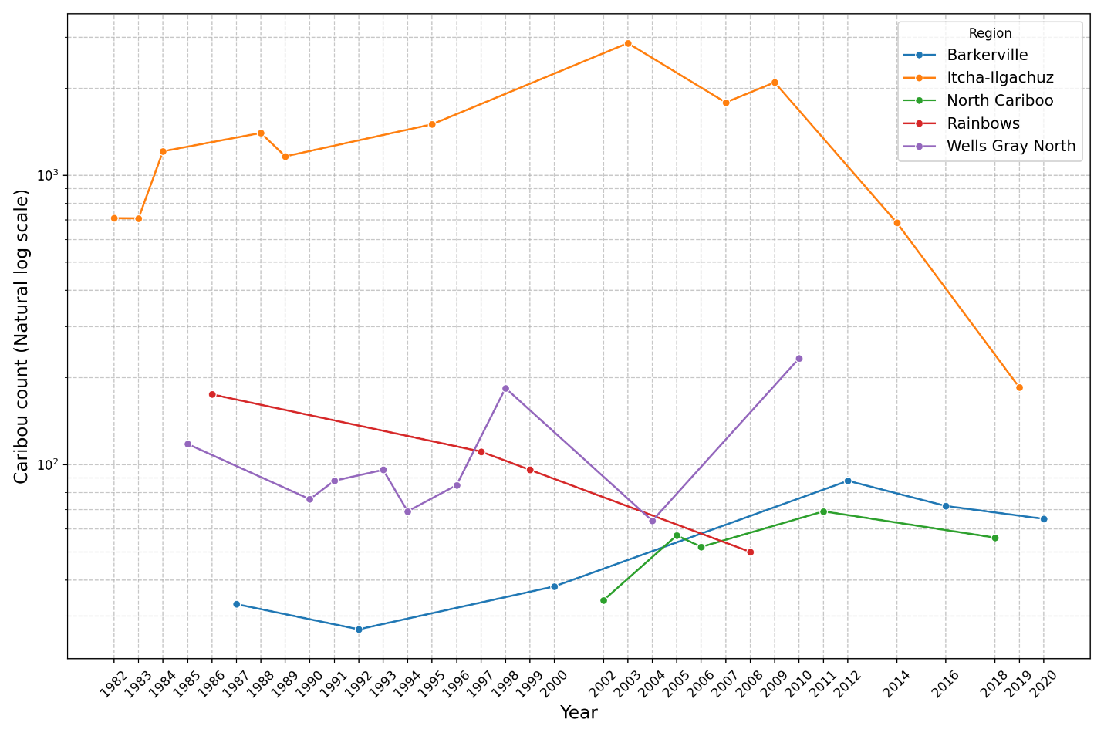

**Figure 4:** Caribou in the Cariboo region of BC

The visualization in Figure 4 demonstrates dramatic change over the years in each subpopulation. Caribou population in Cariboo region shows a stable increasing trend before 2008 except for Rainbow herds. Most subpopulations, except for Wells Gray North, show a decline after the 2010s. Although there was a small recovery trend before the 2010s for all herds, the year 2010 emerges as a critical timestamp, potentially indicating the need for further research into its causes. With the Itcha-Ilgachuz region experiencing a nearly 90% decline within 10 years from 2008, a case study focuses on this herd to identify potential trends using an extinction model for analysis.

**CASE STUDY: CARIBOU IN THE ITCHA-ILGACHUZ REGION**

The case study will focus on analysing Itcha-Ilgachuz herds’ population trend and applying the extinction model to predict the population trend; and recommend the policy action for recovery. Caribou population in Itcha-Ilgachuz shows an increasing trend from 711 in 1980s to hit its peak of 2861 in 2004. After that, it declines more than a thousand in 2006. It slightly recovers in 2009 but drastically drop more than 90% of the survey observation in ten years after.

In 2008 and 2009, Government of British Columbia (2009) reports that there were 358,000 hectares and 199,730 hectares correspondingly attacked by mountain pine beetles leading to dead trees. Itcha-Ilgachuz suffered the most during these two red attacks. Red attacks are defined by the Government of British Columbia (n.d.) as the attack stage from the beetles leading to the inevitable death of the trees. Although there was no research established on the connection between the mountain pine beetle devastation and the caribou population, it is worthy to note that caribous rely on the lichen growing on old tree as a food source to survive. The health of the forest can directly impact to the caribou survival rate (Fortin et al, 2017).

In a control treatment in Itcha-Ilgachuz researched by Waterhouse & Armleder (2005), a small part of the provincial park consist of five blocks of 60 to 80 hectares is divided into a treatment group of partial harvesting and control group of none harvesting. The pre-harvesting period is in 1995 when the park was established as provincial park. The treatment data was extracted in 1998, 2000 and 2004 after the partial harvesting in 1996 was done. It is observed by Waterhouse & Armleder (2005) from the study that partial harvesting in the treatment area has decreased the lichen food source for caribou down to 45 to 56% comparing to no harvesting control area. Although there was sign of lichen recovering after eight years of harvesting, the recovery is insubstantial of only approximately 10% recovery. This indicates the importance of reserving the old growth forest for caribou habitat in Itcha-Ilgachuz Provincial Park.

Applying extinction model (I) from Taylor and Weder (2024), Figure 5 illustrates three scenarios with three level of old growth forest cutting regulation. The green solid line demonstrates the high regulation old growth forest. The high regulation means development deferrals or not logging activity within the protected areas. The yellow line forecasts the little supervision and logging control regulation. The red line shows an absolute extinction with no regulation in old-growth forest logging. With those scenarios are compared against the current statistics in recovery target, genetic diversity threshold, minimum viable population and extinction threshold.

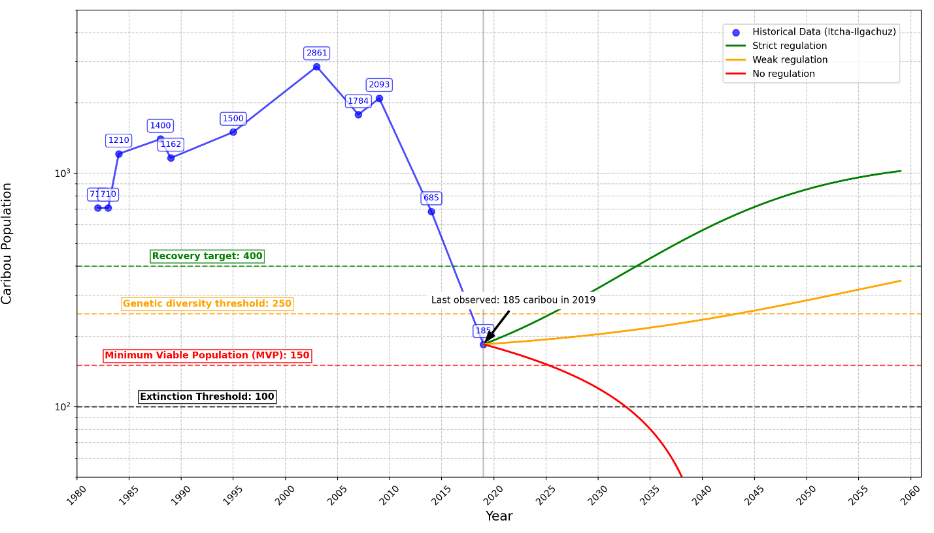

**Figure 5:** Itcha-Ilgachuz population at risk

From Figure 5, three levels of policy application are illustrated. The strict level of regulation including no human inference and harvesting of any kind shows the gradual recovery with increasing return over time. It quickly helps the Itcha-Ilgachuz herds to reach recovery target of 400 in less than 10 years. It will achieve the original population in approximately 35 years. With a weaker regulation including allowing partial harvesting and full log harvesting in effect, it will take the population more than 35 years to the predetermined recovery level. Lastly, if no control is imposed and free harvesting activity is allowed, an immediate extinction is inevitable in 2035. The application of Taylor and Weder (2024) model shows the sensitivity of the animal population relating the human interference and predator activities. It raises the awareness in the conservation responsibility to impose the level of regulation that can affectively recover the herds while balancing other economic interest.

**Old growth forest conservation policies**

**Development deferral**

As the relation between old growth forest and caribou herds is acknowledged by vital environmental policy navigators (Parks Canada, 2023), the mainstream conservation strategy is forest development deferral (Gorley & Merkel, 2020 & Province of British Columbia, 2024). Forestry development deferral is a reservation policy where the commercial logging in certain areas will be delayed and subjected to change in the future (Government of British Columbia, 2025). According to the Government of British Columbia (2025), there are three types of deferrals:

* Voluntary deferrals: Indigenous nations will negotiate with the logging industry which areas should be harvest
* Regulation-based deferrals: establishing an enforcement of Part 13 Forest Act
* Directory deferrals: Provincial government to give orders of conservation directly to BC Timber Sales

Being mathematically explained from model (I), an environment without logging through deferrals will increase caribou carrying capacity. This action is currently performed in Upper Seymour Provincial Park. An area of 2,640 hectares (Cox, 2022) over 10,672 hectares (BC Parks, n.d) are subjected to protect in Upper Seymour Provincial Park under regulated-based deferral. Another 3,070 hectares (Cox, 2022) is protected by voluntary deferrals. Cox (2022) also highlights that the regulated-based deferral decision relies heavily on the caribou population status. With the herds on the brink of extinct, the government is pressured to reserve old growth forest area. However, if this herds disappear, the area may be subjected for commercial logging. This demonstrates how protecting caribous are also protecting the old-growth forest and vice versa.

Parks Canada (2023) also addresses the prey-predator habitat-alternation effect after forestry harvesting occurs. This is illustrated through model (II) where human disturbance is absence in the equation. Post-harvesting, the forestry density leaves open space for wolf as predators to access for hunting caribous and other preys (James et al., 2000). Reservation and reforestation are needed to help regain the natural balance of prey and predator relationship. The solution to this is forestry road deactivation. The restoration of the habitat includes reverse the effect of industrial seismic lines and replanting seeds to block the road from predator access (Central Chilcotin Rehabilitation Ltd., 2025). This proactive conservation strategy along with the industrial development deferral can create effective caribou herds protection through careful forest landscape planning.

**Indigenous-led conservation incentives**

The Indigenous-led projects have played a role in managing old growth forest effectively (Province of British Columbia, 2024). An example of this is Twin Sisters Park or Klinse-Za provincial park and the collaboration between West Moberly First Nations and Saulteau First Nations with the Government of Canada. The size of the provincial park grows nearly 1000 percent from 2,700 hectares in 2020 to approximately 200,000 hectares four years later (Cruickshank & Wood, 2024). This enormous expansion is intended to conserve a larger ecosystem habitat for species at risks such as caribous, grizzly bears and bull trout (Cruickshank & Wood, 2024). The trade-off cost of this conservation movement is $46 millions in financial aids to directly affected forestry stakeholders and tenure holders. To offset the opportunity cost of non-harvesting in Northern BC, South Peace Mackenzie Economic Diversification and Stabilization Trust was initiated by the Government of British Columbia (2022). The fund would boost the local economies with $1 million showing the government commitment to stand with the Indigenous communities in saving caribous through forestry conservation.

Another highlight of Government of British Columbia’s financial commitment to old growth conservation is investing $300 millions in creating an Indigenous-led program (Verde, 2023). This program along with other policies are aimed to provide enforced protection to 30% of old growth forest area in British Columbia by 2030. The funding is intended to invest in Indigenous stewardships and their policy making. This could lead to potential changes, as multiple proposals for old-growth forest policies require funding to be implemented.

Ancient Forest Alliance (n.d) also recommend strategic policies in aligned with the incentives mentioned above. The financial support from the government in 2023 for a new Indigenous-led program, according to Ancient Forest Alliance (n.d), will provide capacity to build conservation strategy consulting through the First Nation. Not only that, the funding also offsets the trade-off cost of logging deferrals and revenue lost. The impact of this strategy will help small Indigenous community with economic growth while maintaining their guardian duties and their relationship with the land. Moreover, the organization also suggests expanding second growth commercial forestry. This will minimize the impact of logging the current old growth forest while balance the need of demand and supply for wood products.

**Discussion and recommendations**

From the case study of Itcha-Ilgachuz, it is observed that the herd trending has significant fluctuations over the past decades with a peak in 2004 followed by a dramatic decline. It is suspected that the red attacks and logging activities are responsible for the big drop. The relationship between caribou survival rate and old-growth forest preservation is significantly positive. This is due to the high resource of lichen, caribou main food source, allocates in old growth forest areas. Research by Waterhouse & Armleder (2025) further supports the importance of preserving old growth forest with the outcome indicates partial harvesting greatly affect the level of lichen availability over long-term periods.

The application of Taylor and Weder (2024) extinction model to Itcha-Ilgachuz herds provides insightful projections of caribou future population under different level of regulations. The findings suggest that strong regulation on old-growth forest logging can accelerate caribou recovery rate to achieve beyond the minimum recovery target in less than ten years. The minimum to zero effort in regulation will lead to the herd extinction in 2035. This further highlights the need to implement effective and immediate conservation policies to recover Itcha-Ilgachuz herds. From the model, it is recommended to increase the strict level of regulation in monitoring logging activities.

Another important aspect of caribou conservation is the impact of logging on predator-prey dynamics. Clear-cut logging creates open landscapes that accelerate the predator access to caribous and decreasing the caribou’s carrying capacity. The implementation of forestry road deactivation, habitat restoration and old growth forest preservation is necessary to mitigate the impacts of logging on the ecosystem. This can be collaborated with local communities to monitor and navigate suitable caribou recovery strategies in regional-focused scale.

Forestry management strategies including development deferrals plays an important role in conservation. Three level of deferrals including voluntary, regulation-based, and directory deferrals allows the flexibility in planning. Nevertheless, Upper Seymour Provincial Park case illustrates the success of the policies depends great on the status of the caribou population. Without effective intervention, the decline of caribou populations may result in the removal of conservation protection and ultimately leading to an opening of commercial logging. It is encouraged to expand further the development deferral programs that continue to push for more caribou habitat conservation and strengthening enforcement laws under Forest Act to prevent unauthorized logging activities.

Indigenous-led conservation projects have major progress in preserving old-growth forests and caribou habitats. The expansion of Twin Sisters Park, highlighted by the collaboration between the Indigenous and government partnerships in variety of community-driven conservation initiatives, brings a great movement towards preserving old growth forest success. Last but not least, government financial commitments, such as the $300 million investment in Indigenous-led programs, reinforce the potential for sustainable conservation policies that balance the interest of ecological preservation and economic support for affected stakeholders. Further Indigenous-led conservation initiatives and consulting with indigenous communities will foster Truth and Reconciliation and heal the people’s relationship with the land.

**CONCLUSION**

Caribou conservation effort has been practiced through variety means of human inference such as maternal penning, predator control and logging road deactivation. Those efforts are effective in short term. Combining them with caribou habitat conservation is needed to create a sustainable plan in long term. The Itcha-Ilgachuz caribou case study has shown how different level of regulations can impact the outcome of the herd growth. The extinction model analysis highlights the direct impact of forest management policies on caribou survival. The long-term plan is combining different levels of effort including consulting with Indigenous communities to foster region-focused solutions, extending development deferral programs, and strengthening the logging regulation to conserve caribou habitat. By balancing the ecological needs with economic considerations, policymakers can secure the survival chance of caribou species while promoting economic growth in rural areas and community well-being. This paper is dedicated to call for immediate actions on adapting efficient policies and navigating against the ticking time of caribou extinction over in British Columbia.

**References**

Ancient Forest Alliance. (n.d.). *Provincial Old Growth Protection Strategy*. <https://ancientforestalliance.org/our-work/old-growth-campaigns/provincial-old-growth-protection-strategy/>

BC Parks. (n.d.). Upper Seymour River Park. Province of British Columbia. <https://bcparks.ca/upper-seymour-river-park/>

Central Chilcotin Rehabilitation Ltd. (2025, February 4). How First Nations are rehabilitating 'predator super-highways' in the Cariboo for the caribou. *Canadian Biomass Magazine*. <https://www.canadianbiomassmagazine.ca/how-first-nations-are-rehabilitating-predator-super-highways-in-the-cariboo-for-the-caribou/>

Cichowski, D., Sutherland, G., Mcnay, R., & Sulyma, R. (2022). Direct and Indirect Effects of Habitat Disturbances on Caribou Terrestrial Forage Lichens in Montane Forests of British Columbia. *Forests*. <https://doi.org/10.3390/f13020251>.

Conn, P., Thorson, J., & Johnson, D. (2017). Confronting preferential sampling when analysing population distributions: diagnosis and model‐based triage. Methods in Ecology and Evolution, 8. <https://doi.org/10.1111/2041-210X.12803>.

Cox, S. (2022, November 25). BC Timber Sales plans to log old-growth rainforest, home to endangered caribou herd. *The Narwhal*. <https://thenarwhal.ca/bc-logging-endangered-caribou-habitat/>

Cruickshank, A., & Wood, S. K. (2024, June 14). This new provincial park is the largest created in B.C. in a decade*. The Narwhal*. <https://thenarwhal.ca/klinse-za-twin-sisters-provincial-park-bc/>

Ehlers, L. P., Johnson, C. J., & Seip, D. R. (2016). Evaluating the influence of anthropogenic landscape change on Wolf Distribution: Implications for woodland caribou. *Ecosphere*, *7*(12). https://doi.org/10.1002/ecs2.1600

Fortin, D., Barnier, F., Drapeau, P., Duchesne, T., Dussault, C., Heppell, S., Prima, M., St‐Laurent, M., & Szor, G. (2017). Forest productivity mitigates human disturbance effects on late-seral prey exposed to apparent competitors and predators. Scientific Reports, 7. https://doi.org/10.1038/s41598-017-06672-4.

Government of British Columbia. (2009). 2009 Southern Interior Forest Region: Forest health overview. <https://www2.gov.bc.ca/assets/gov/environment/research-monitoring-and-reporting/monitoring/aerial-overview-survey-documents/2009_sifr_fh_overview_booklet.pdf>

Government of British Columbia. (n.d.). History of the mountain pine beetle infestation. https://www2.gov.bc.ca/assets/gov/farming-natural-resources-and-industry/forestry/forest-health/bark-beetles/history_of_the_mountain_pine_beetle_infestation.pdf

Government of British Columbia. (2022, April 11). Northeast economies get $10-million boost. <https://news.gov.bc.ca/releases/2022LWRS0001-000539>

Government of British Columbia. (2016, February). *ILRR Quick Reference Guide Forest Data ... - gov.bc.ca*. ILRR Quick Reference Guide Forest Data Reference Guide. <https://www2.gov.bc.ca/assets/gov/data/geobc/ilrr-qr-forest-data.pdf>

Government of British Columbia. (2025, March 12). Caribou Herd Locations for BC. Open Government Portal. <https://open.canada.ca/data/en/dataset/2b217585-f48d-4d9f-b7ba-746909ac35ca>

James, A., & Stuart-Smith, A. (2000). Distribution of Caribou and Wolves in Relation to Linear Corridors. Journal of Wildlife Management, 64, 154-159. <https://doi.org/10.2307/3802985>.

Johnson, C. J., Mumma, M. A., & St‐Laurent, M. (2019). Modeling multispecies predator–prey dynamics: Predicting the outcomes of conservation actions for Woodland Caribou. *Ecosphere*, *10*(3). https://doi.org/10.1002/ecs2.2622

Kutz, S., & Tomaselli, M. (2019). “Two-eyed seeing” supports wildlife health. Science, 364, 1135 - 1137. <https://doi.org/10.1126/science.aau6170>

Maher, S. M., Fenichel, E. P., Schmitz, O. J., & Adamowicz, W. L. (2020). The economics of conservation debt: a natural capital approach to revealed valuation of ecological dynamics. *Ecological Applications, 30*(6):e02132. 10.1002/eap.2132

Maltman, J. C., Coops, N. C., Rickbeil, G. J., Hermosilla, T., & Burton, A. C. (2024). Quantifying forest disturbance regimes within Caribou (Rangifer tarandus) range in British Columbia. *Scientific Reports, 14*(1). [https://doi.org/10.1038/s41598-024-56943- 0](https://doi.org/10.1038/s41598-024-56943-%200)

McKinnon, G. (1996). A Mountain Caribou Strategy for British Columbia. *Rangifer*, 16, 149-152. <https://doi.org/10.7557/2.16.4.1236>.

Mcnay, R., Lamb, C., Giguere, L., Williams, S., Martin, H., Sutherland, G., & Hebblewhite, M. (2022). Demographic responses of nearly extirpated endangered mountain caribou to recovery actions in Central British Columbia. *Ecological Applications*, 32. <https://doi.org/10.1002/eap.2580>.

Ministry of Forests. (2024, May 21). *Old growth definitions and values*. Province of British Columbia. <https://www2.gov.bc.ca/gov/content/industry/forestry/managing-our-forest-resources/old-growth-forests/old-growth-values>

Newsome, T., Brown, K., & Nemec, A. (2016). Effects of opening size and microsite on performance of planted tree seedlings in high-elevation Engelmann spruce–subalpine fir forests managed as mountain caribou habitat in British Columbia. *Forest Ecology and Management*, 370, 31-44. <https://doi.org/10.1016/J.FORECO.2016.03.001>.

Parks Canada. (n.d.). Caribou. Glacier National Park. <https://parks.canada.ca/pn-np/bc/glacier/nature/faune-flore-fauna-flora/caribou>

Gorley, A. & Merkel, G. (2024). ​ A new future for old forests: From review to action: A report out on actions toward resilient ecosystems, communities and economies in B.C. ​ <https://www2.gov.bc.ca/assets/gov/farming-natural-resources-and-industry/forestry/stewardship/old-growth-forests/strategic-review-20200430.pdf>

Government of British Columbia. (2025, January 30). *Old growth deferral areas*. Province of British Columbia. <https://www2.gov.bc.ca/gov/content/industry/forestry/managing-our-forest-resources/old-growth-forests/deferral-areas>

Government of British Columbia. (n.d.). Wildlife Species Inventory Survey Summary. B.C. Data Catalogue. <https://catalogue.data.gov.bc.ca/dataset/wildlife-species-inventory-survey-summary-publicly-available>

Stevenson, S. (1990). Managing second-growth forests as caribou habitat. *Rangifer*, 10, 139-144. <https://doi.org/10.7557/2.10.3.844>.

Taylor, M. S., & Weder, R. (2024). On the Economics of Extinction and Possible Mass Extinctions. *Journal of Economic Perspectives*, *38*(3), 237-260. <http://doi.org/10.1257/jep.38.3.237>

Verde, J. (2023, December 12). *New Indigenous-led, BC old growth forest program*. Happy Eco News. <https://happyeconews.com/new-indigenous-led-bc-old-growth-forest-program/>

Watt, J. (2024, September). One last shot to protect old-growth forests in British Columbia [Video]. TED. <https://www.youtube.com/watch?v=enF8Zf4EPNg>

Waterhouse, M. J., & Armleder, H. M. (2005). Itcha-Ilgachuz Alternative Silvicultural Systems Project 1995-2005: Research update (Extension Note 02). B.C. Ministry of Forests and Range, Southern Interior Forest Region.

Winder, R., Stewart, F., Nebel, S., McIntire, E., Dyk, A., & Omendja, K. (2020). Cumulative Effects and Boreal Woodland Caribou: How Bow-Tie Risk Analysis Addresses a Critical Issue in Canada's Forested Landscapes. , 8. <https://doi.org/10.3389/fevo.2020.00001>.

1. Accessed from BC https://governmentofbc.maps.arcgis.com/apps/MapSeries/index.html